

Burp Intruder: Cluster-Bomb Fuzzing of Multi-field Login

October 2025

Aldanah Alanzi
Jumanah Alshehri
Layan Alghamdi
Alanoud Alqahtani

1. Purpose and Scope
This project demonstrates why a web application firewall (WAF) matters by comparing two clear scenarios: an unprotected application versus the same application protected by a ModSecurity rule set. Using Burp Suite Intruder’s Cluster-Bomb mode, we systematically fuzz correlated username/password pairs against DVWA in an isolated lab, then enable threshold rules that react to repeated failed attempts and repeat the tests. 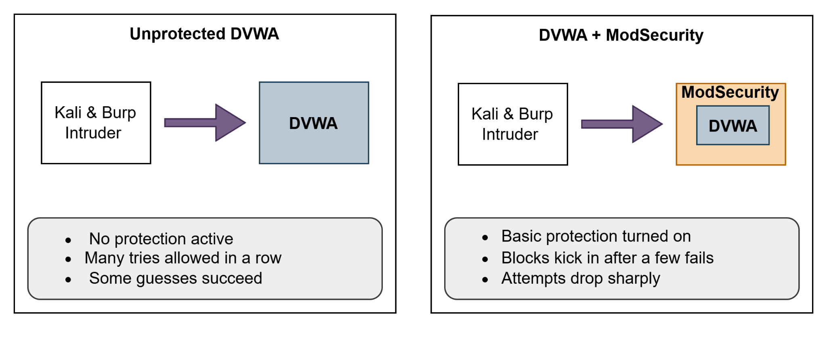
We measure and compare success rates, observed blocks, and log evidence (Burp exports, Apache logs, ModSecurity audit records) to show what succeeds without a WAF, what is stopped when threshold protections are active, and how those differences appear during a short live demo and in a mitigation checklist suitable for grading.

2. Tools and Setup
The experiment was conducted on a single virtual machine within an isolated private network that hosted both the attack tools and the target application. Kali Linux and Burp Suite (browser proxying configured using FoxyProxy) were used to generate attacks against DVWA, which ran on Apache with ModSecurity enabled.
The primary tools are Burp Suite Intruder (Cluster-Bomb) to set up multi-field payload combinations and ModSecurity to enforce threshold-based responses. Evidence is collected from access.log, error.log, and audit.log, and all Intruder results are exported as log for analysis.
WAFW00F was used to determine if DVWA uses a Web Application Firewall (WAF), and the results showed that it does not have any WAF protection in place.

3. Baseline Conditions
The baseline simulates a common posture: a vulnerable application with no WAF present. DVWA is deployed with a low security level: no per-user lockout, no CAPTCHA, and no rate-limiting. ModSecurity is installed but set to off or DetectionOnly, so it does not alter responses. This state allows the team to observe the raw effect of Cluster-Bomb fuzzing without interference.
To make the experiment auditable, we create known test credentials, verify normal login flows, and enable logging at default detail. We also confirm that the DVWA login accepts repeated attempts from the same client without delay.

4. Attack Method: Cluster-Bomb Fuzzing
Cluster-Bomb is designed to explore the Cartesian product of two payload lists. We prepare two canonical files seed_usernames.txt and seed_passowords.txt: each containing plausible values: one known-valid pair is retained as a control to verify that success conditions are detected correctly. Within Burp Intruder, the login request is captured and the two form fields are marked as positions. Attack Type = Cluster-Bomb with seed_usernames.txt mapped to Position 1 and seed_passowords.txt to Position 2. We execute a short pilot (e.g., 6×6) at conservative concurrency to validate that responses and logs appear as expected. We then run a pass using the full lists, holding the request rate constant so the baseline and post-mitigation runs are directly comparable. All Intruder results (status code, response length, timestamp, payload pair) are exported in a folder.

5. Evidence and Evaluation
This section outlines the collected evidence and how it supports our conclusions. For each item below, a representative sample of the relevant logs or configurations is shown here, while the complete logs are available in the GitHub repository linked in the Appendix.
- Cluster Bomb Test Results: Before and After ModSecurity
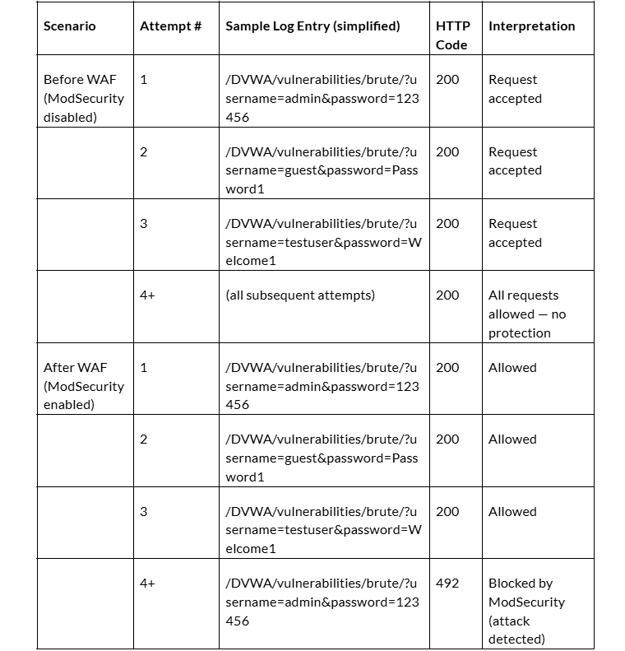
This table summarizes the test results observed before and after enabling the Web Application Firewall (WAF) using ModSecurity. It shows how the server responded to multiple login attempts before and after protection was applied.
After enabling ModSecurity, the first three login attempts were allowed (HTTP 200), while subsequent ones were blocked (HTTP 492).

- ModSecurity rules and configurations applied, which will be triggered after 3 attempts.
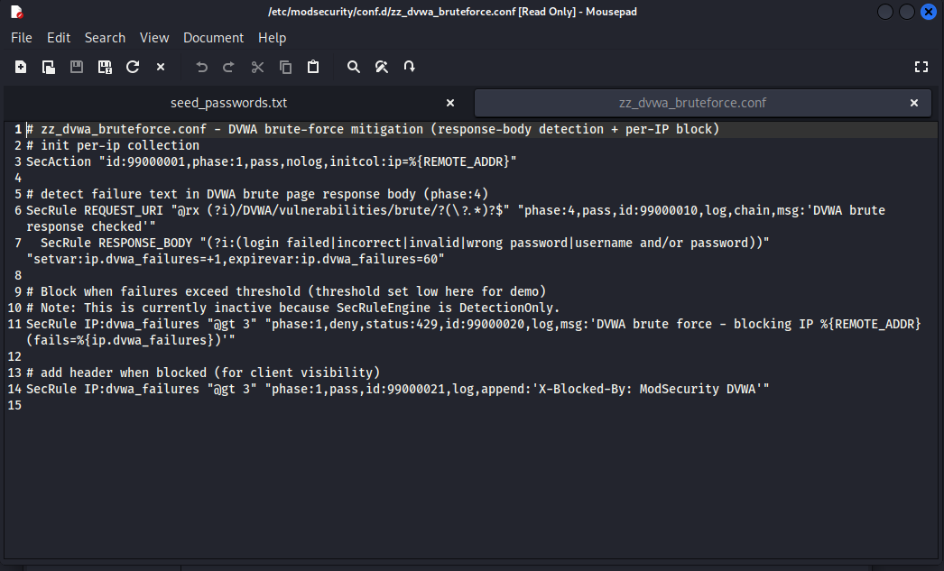
- Logs after enabling ModSecurity, which shows the attempts being blocked.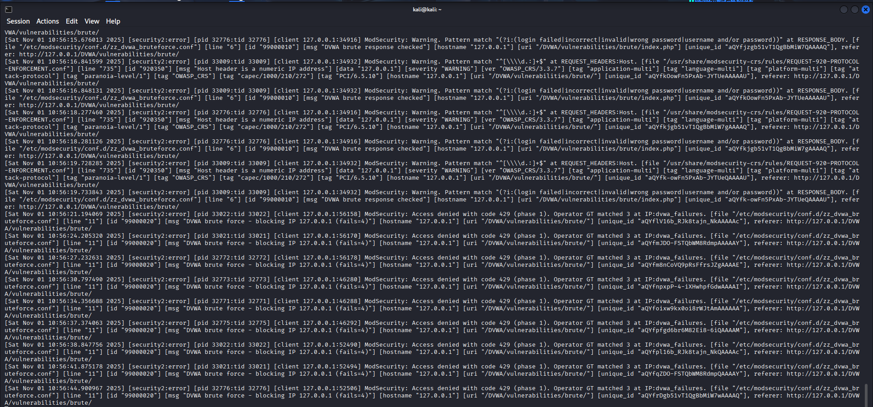
Server-side, we extract timestamp-bounded slices of access.log to show the pattern of requests and resulting status codes. The ModSecurity audit.log is filtered for the relevant rule IDs to document when thresholds are crossed and what action was taken. Where applicable, we annotate a short excerpt to show the matched field (IP or username counter), the configured action (deny), and the audit trail identifier

- wafw00f not detecting a waf deployed on DVWA
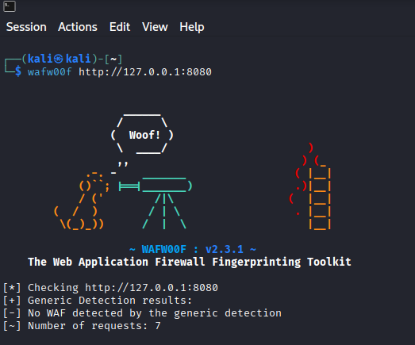
- wafw00f detecting a waf deployed on DVWA
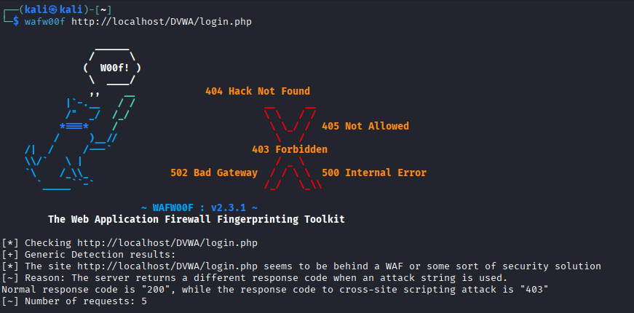

6. Mitigation Design
The mitigation is a ModSecurity policy named zz_dvwa_bruteforce.conf. It mitigates brute-force attempts against the DVWA login/brute endpoints and maintains counters for failed logins keyed by IP using persistent collections. When the number of failures exceeds 3 times, the rule issues a temporary deny for 60 seconds, logs the event. The policy is first deployed in DetectionOnly to verify that counters evolve as expected without disrupting traffic; it is then switched to deny.
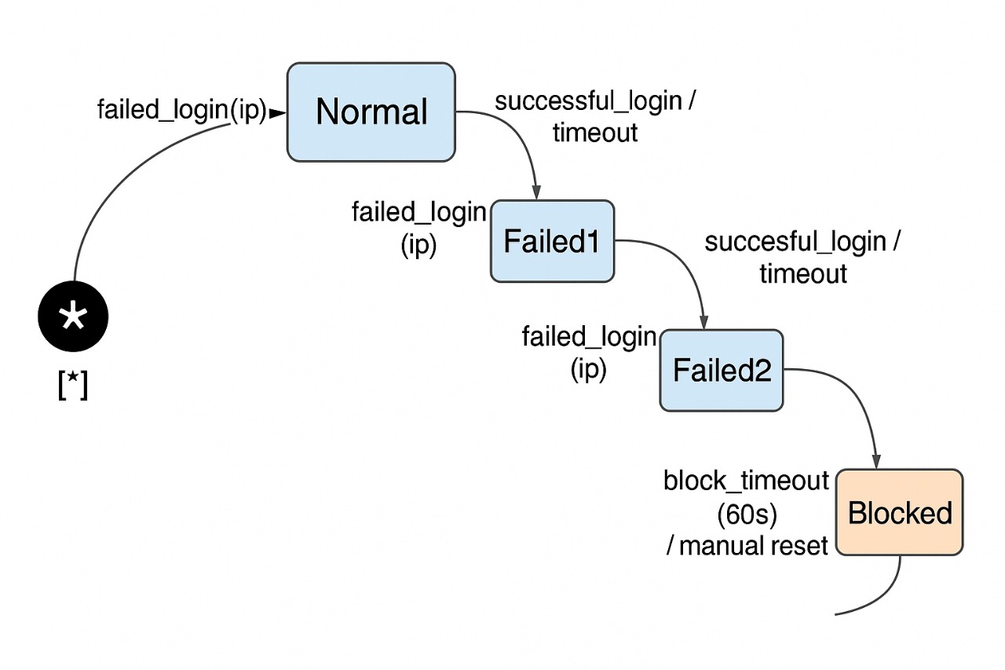
This approach is intentionally simple and explainable. It demonstrates reduction in successful combinations and an early deny point without introducing application changes. For production contexts we recommend strengthening the posture with application-level lockout/backoff, CAPTCHA on suspicious flows, and lightweight rate limiting at the reverse proxy. These measures layer well with ModSecurity and reduce reliance on a single control.

7. Conclusions and Implications
The baseline confirms that a vulnerable login accepting unlimited attempts is readily exercised by Cluster-Bomb: combinations can be explored efficiently, and success indicators are easy to spot in Burp and server logs. Once ModSecurity threshold rules are enabled, the attack’s effectiveness drops sharply: time-to-first-deny is short, block rate increases substantially, and the same payloads that succeeded previously are rejected under unchanged conditions. The logs provide a clear, auditable record of detection and enforcement.
While a tuned WAF rule materially raises the cost of automated guessing, it is not a complete solution. Distributed sources, NATed clients, and application-specific behaviors may require different thresholds and additional safeguards. The recommended next step is to finalize the wafw00f fingerprints, include the summarized metrics tables (baseline vs. mitigated), and—if time allows—repeat runs at a second request rate to illustrate how protection scales without degrading legitimate user experience.

